**CN LAB#04**

**SUBMITTED BY: AYESHA ZIA (20K-0414)**

**QUESTION#01**

In caching, the age contains the time in seconds for which the object was present in a proxy cache and it is usually close to zero. Whereas, expires is a header that specifies a particular date or time at which the cached resource will be expired.

**QUESTION#02**

The four main grouping of HTTP headers are:

* HTTP Response Header
* HTTP Request Header
* HTTP Entity Header
* HTTP General Header

**QUESTION#03/4**



IMPLEMENTATION:





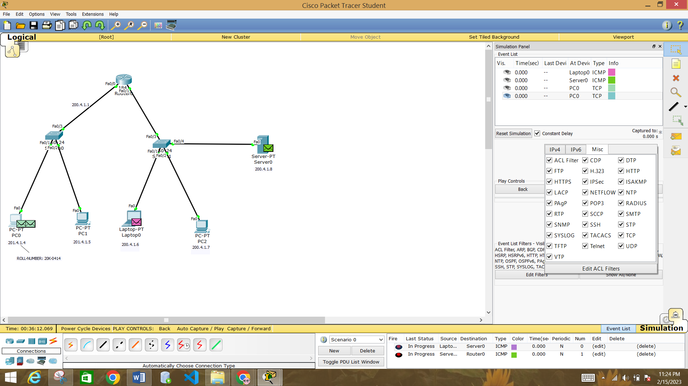







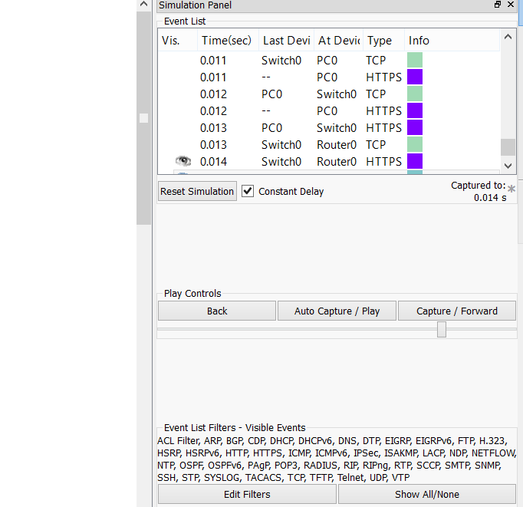

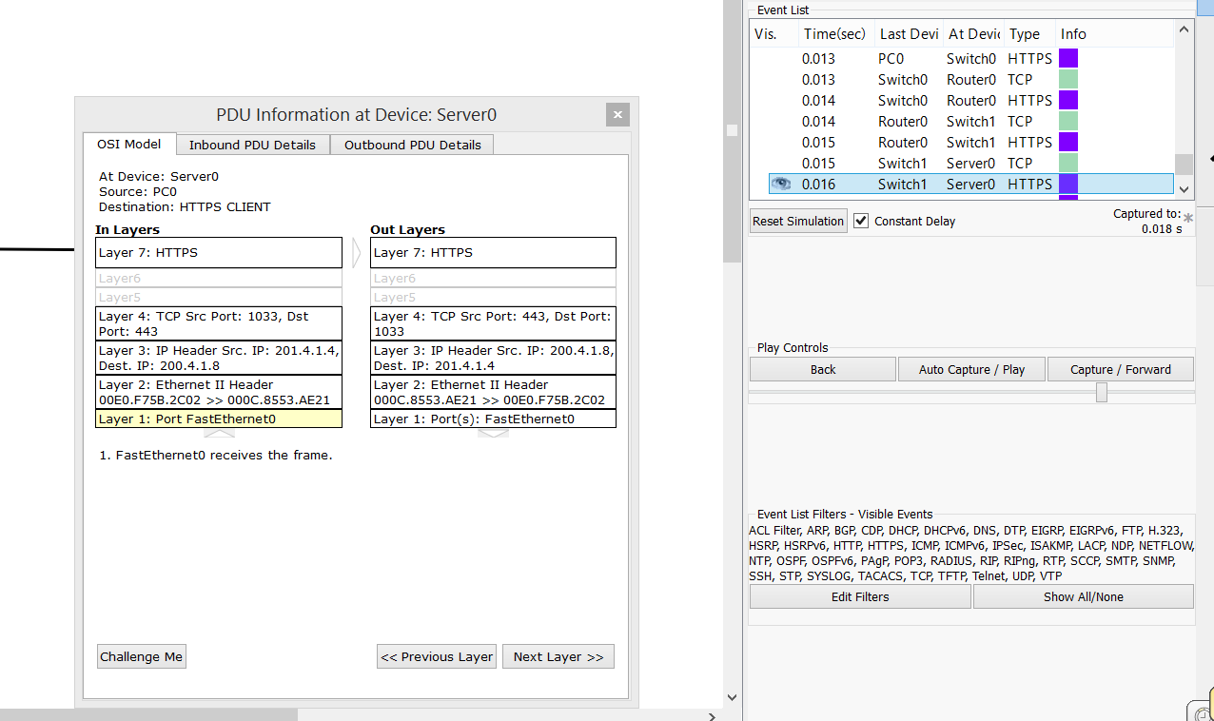



**What I understood:** HTTPS is a more secure version of HTTP as it contains more layers so the url link is less vulnerable to malicious attacks.